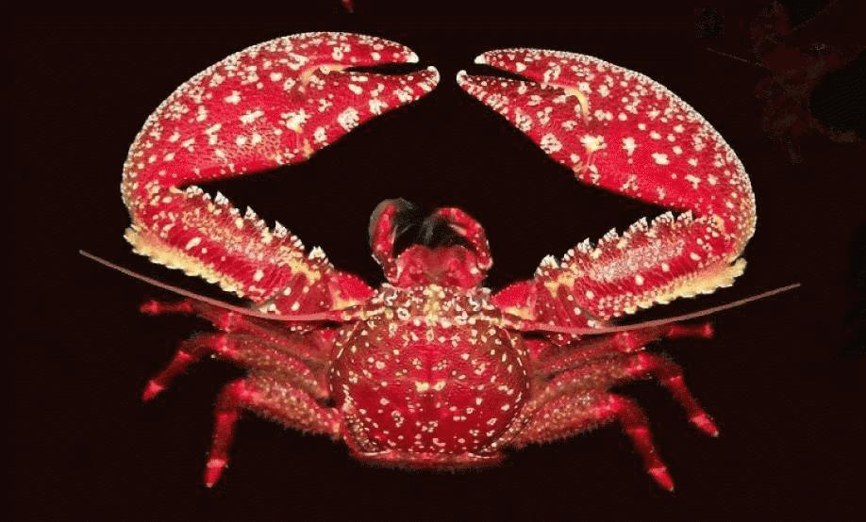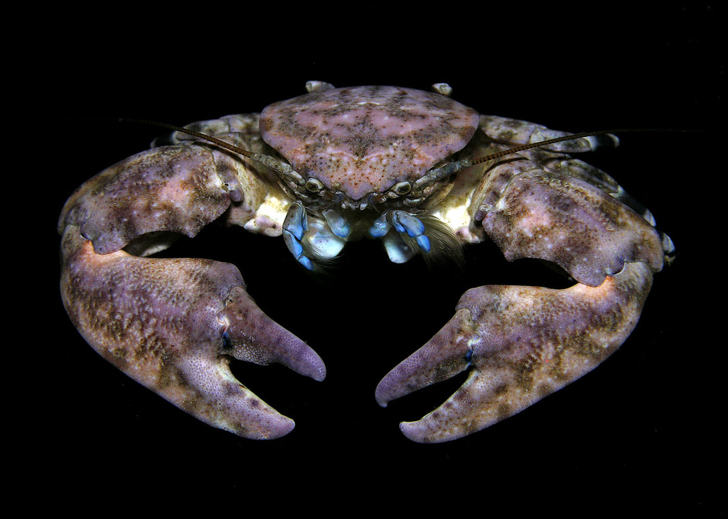

PETEE

PEDE

ALAN

HOPL

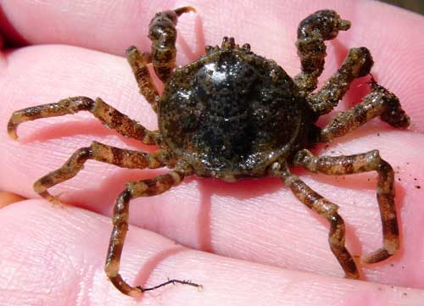



TADE

CAGE

HECU

ANAL

PHPL

ANACANAL

CASE

GAGA

LOAL

ATCH

TENI

ODPE

LOAL

MEGE

PACH

PAAD

BOCH

TAMA

ROFO

HECH

COCO

PABA

HAPL